Meerkat Hopscotch Game

Learning intentions:
- Understand barriers/threats to meerkat survival
- Suggest enablers that could counteract barriers/threats
- Practice coordination through hopscotch activity

Description:
- A 3x8 string grid is laid out on the grass (or chalked). Each grid is approx 600mm x 500mm. Meerkats start at one end. They are waking up from within their burrows and heading out into the scrub/desert to feed but have to negotiate the grid first. On the other side of the hopscotch grid, out at in the desert, is meerkat food…. YUMMY scorpions and snakes.

- Meerkats cross over the grid/sand to get the food by hopping.

- While they were gone, their environment has changed so when they return to their burrows they have to cross the obstacles/threats/barriers – see cards below.

- Re-run the trip from burrow to desert (and vice versa) several times. Each time, add another barrier/threat card so the hopscotching becomes steadily harder. If a student steps on string or grid with card in it they must repeat. After running the journeys several times, start introducing enabler cards – see below in italics.

Safety considerations:
- Make sure that surface is even and that journeys are not crowded and that there is a large ‘stand-back’ space beyond the ends of the string grid.

Equipment:
- Cards – laminated with pictures/words (see below).
- 600mm x 500mm string grid.

Location:
- Any flat grassy or sandy space.

Time:
- 15 minutes to 30 minutes

Student processing/reflection:
- Pose questions about threats. Discuss each card as you show it. At end of activity, prompt students to suggest what they can do to ensure meerkat survival. Discuss threats to other fauna.

Possible adaptations:
Tuatara Hopscotch, Kiwi Hopscotch – basically any animal as a context for your study.

Card templates:
Martial Eagle; Jackal; Wild cat; Cobra; Puff-header snake; Competing gang; Flooding; Starvation; Habitat loss; Disease; Tunnel collapse

The following are enabler cards: Education; Protected habitat; Skilled sentry; Mobbing; Good den making; Territories

Martial Eagle

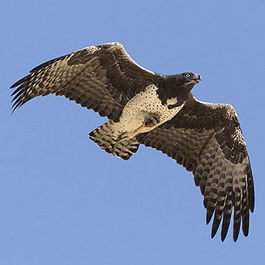

Jackal

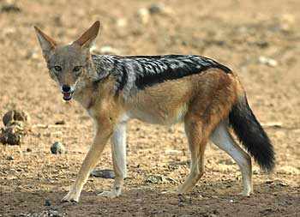

Wild Cat

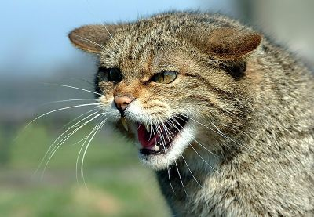

Cobra

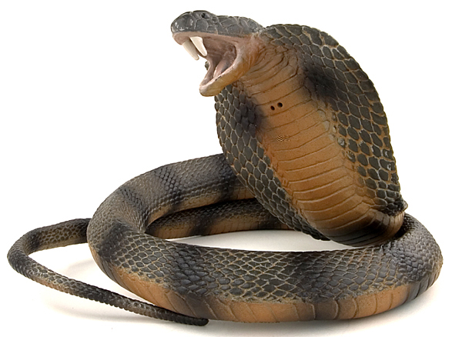

Puff-header snake

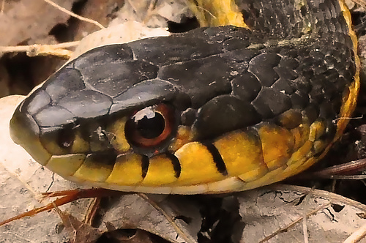

Flooding

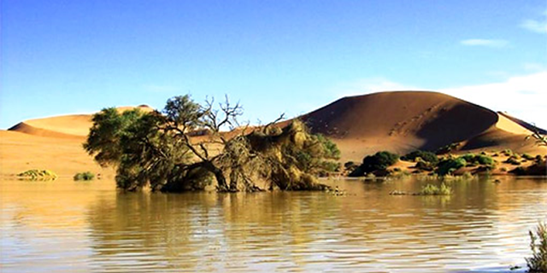

Another gang

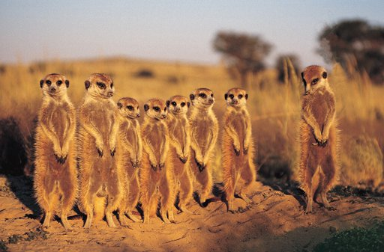

Starvation

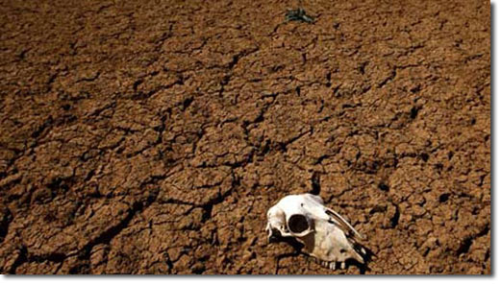

Spreading cities

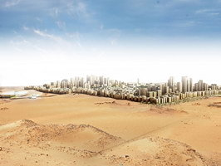

Disease

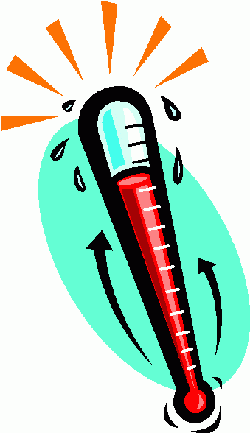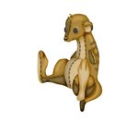

Tunnel collapse

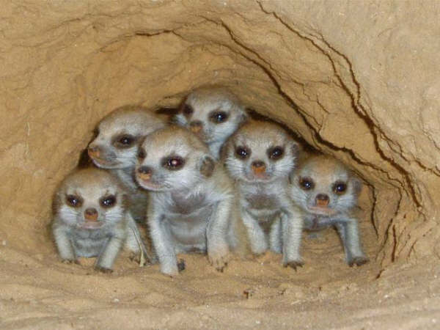

Climate change

Protected habitat

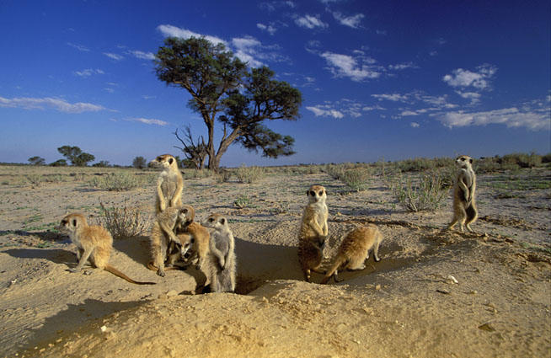

Education

Mobbing

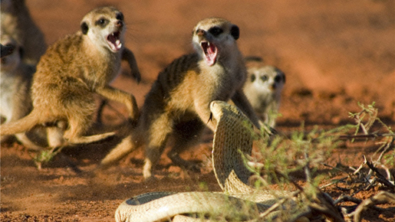

Skilled sentry

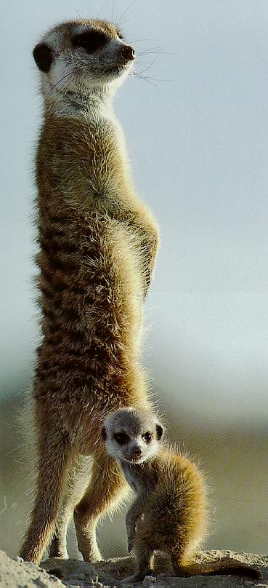

Good den making

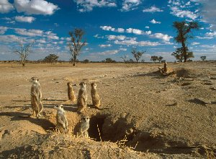

Good parenting

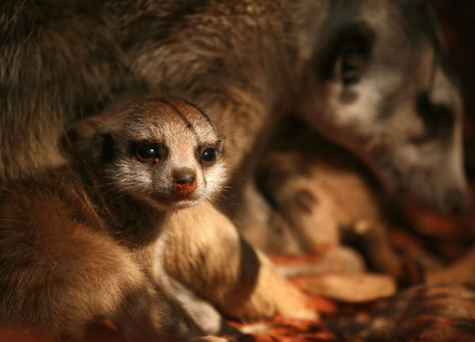

Immunity to poison

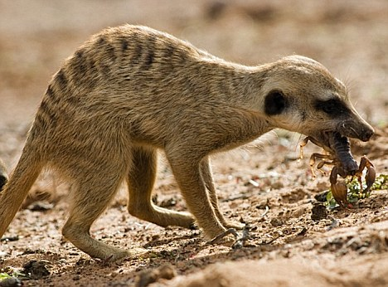

Territories

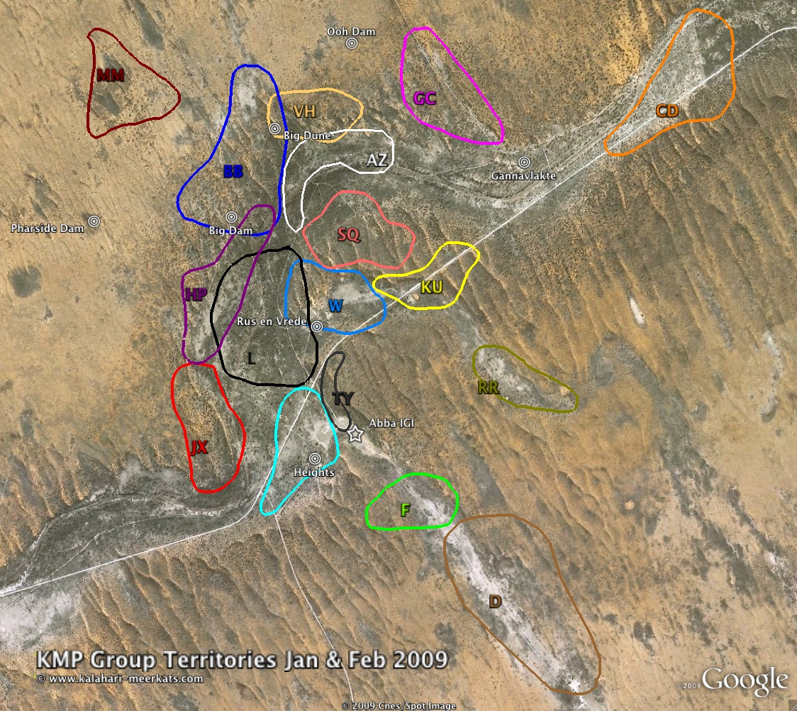

Tourism?

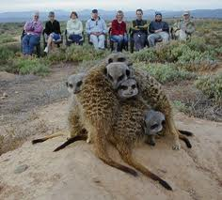

Join groups

