**Tools: Decision Making Matrix (an example)**

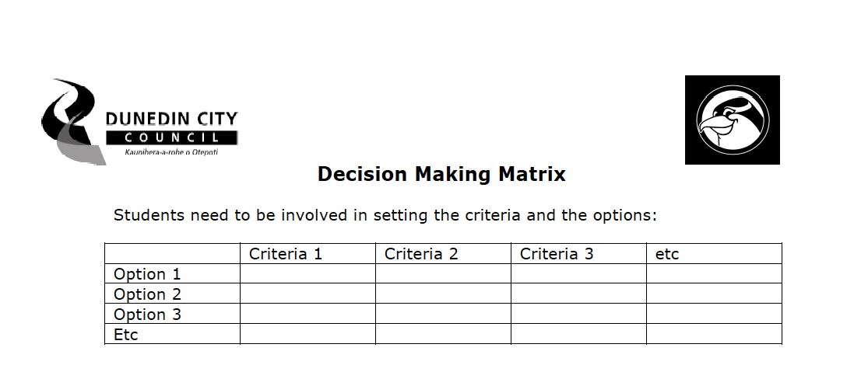

**Example: Decision Making Matrix for choosing a Composting System:**

